Task 1: Networking Setup
- Create a Virtual Network (VNet).
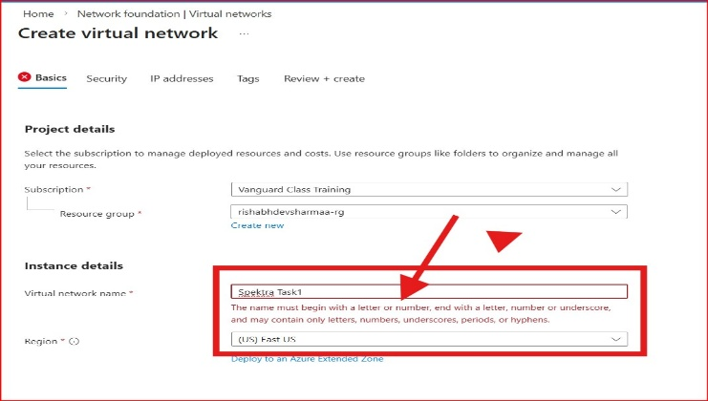
- Define a Subnet within that VNet.
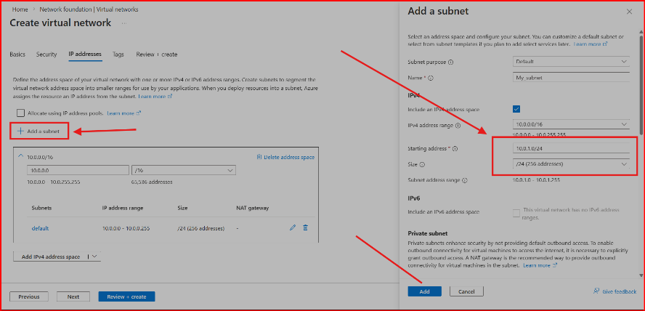

- Goal: Ensure the address space is sufficient for future scaling.
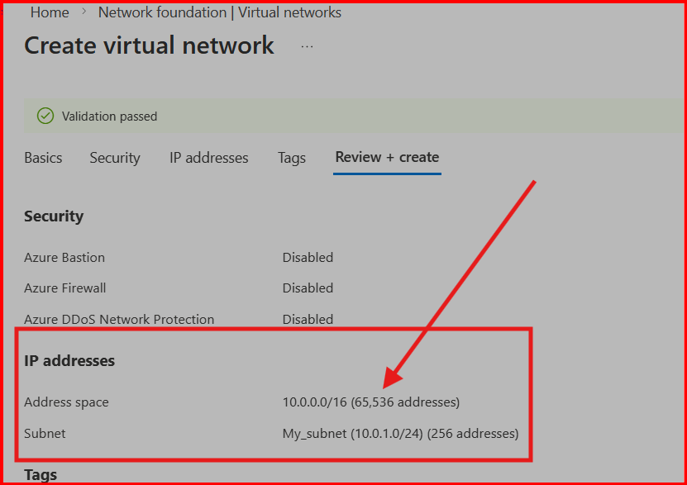

Task 2: Security & Entry Points
- Create a Network Security Group (NSG).
- 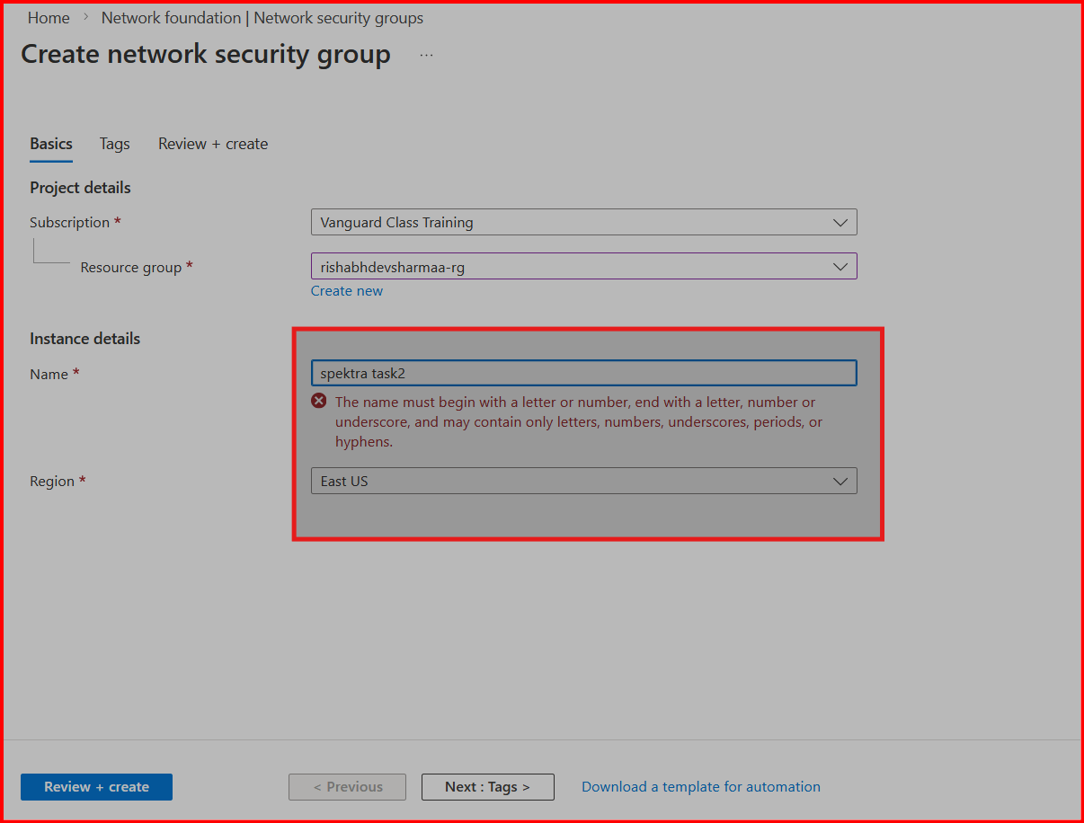
- Configure a rule that allows you to remotely manage the VM.
- 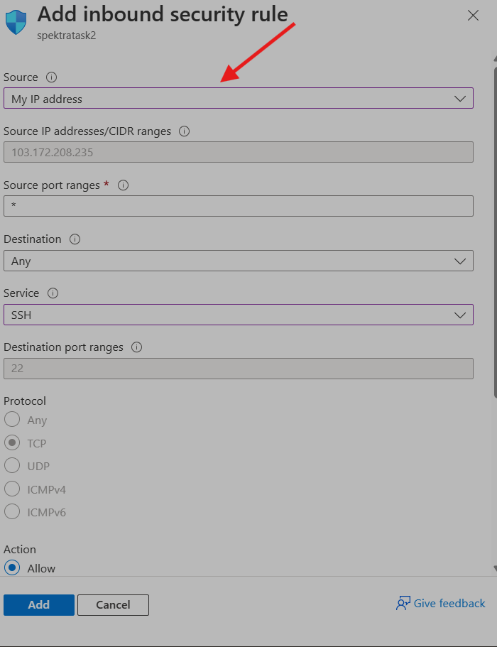

- Create a Public IP Address to allow external connectivity.

- 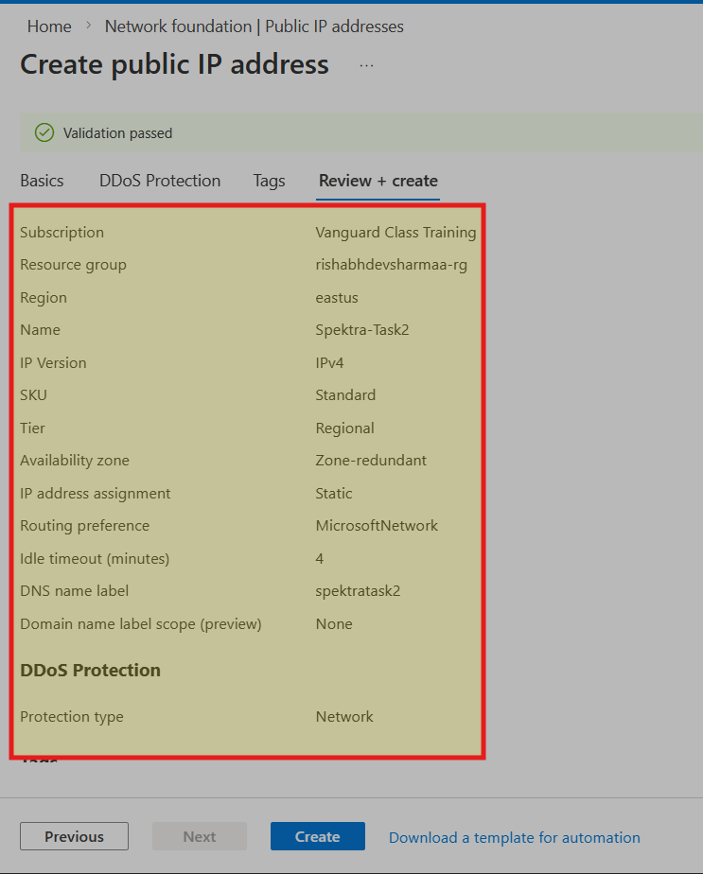
- 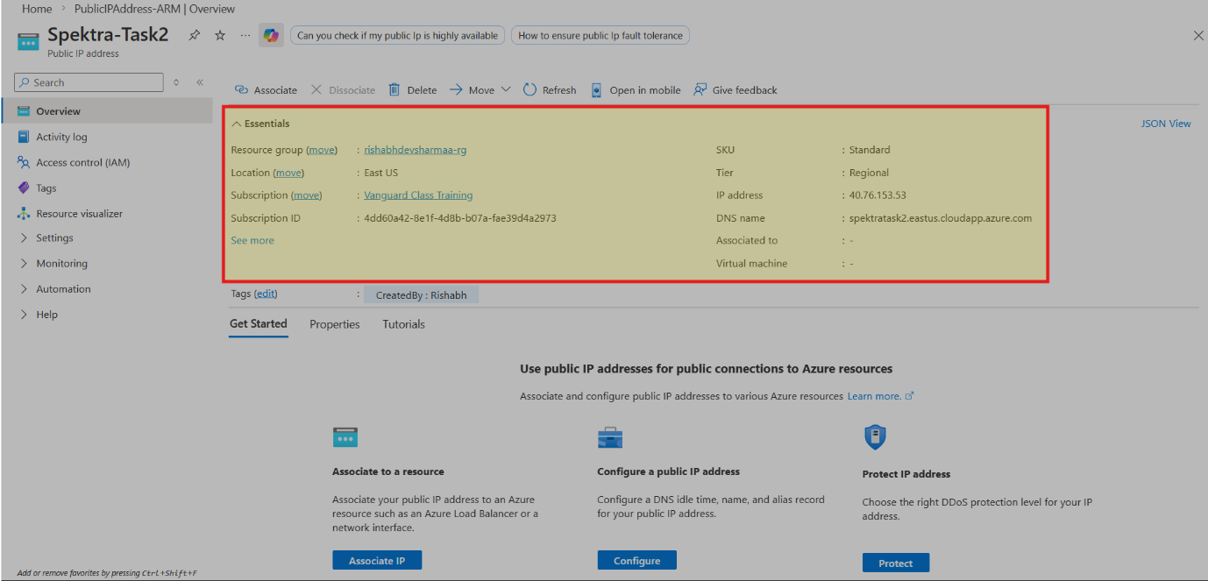

Task 3: The Connection Layer
- Create a Network Interface (NIC).
- 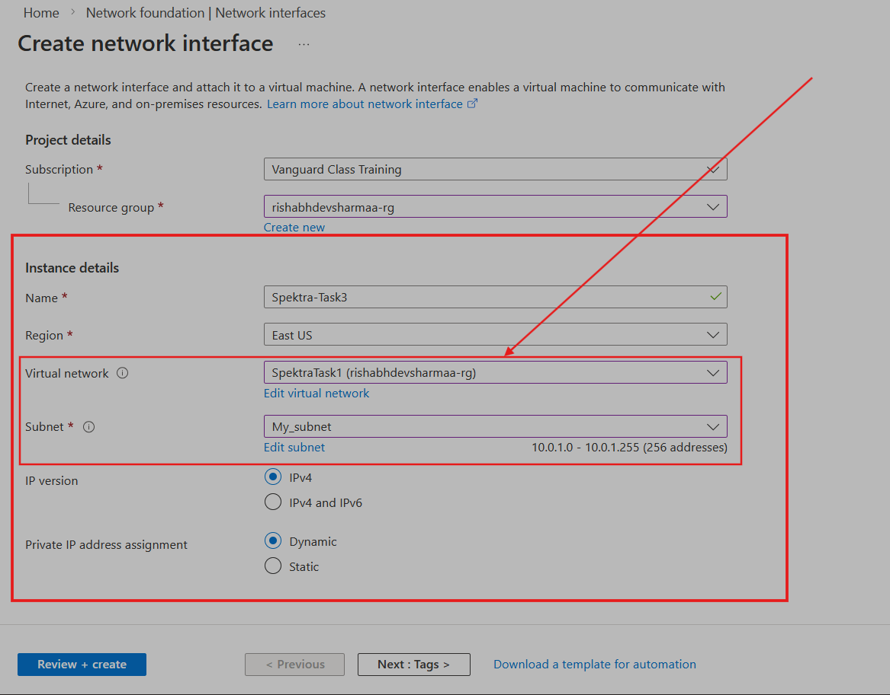

- Manually associate the VNet, Subnet, NSG, and Public IP you created in the previous steps.
- 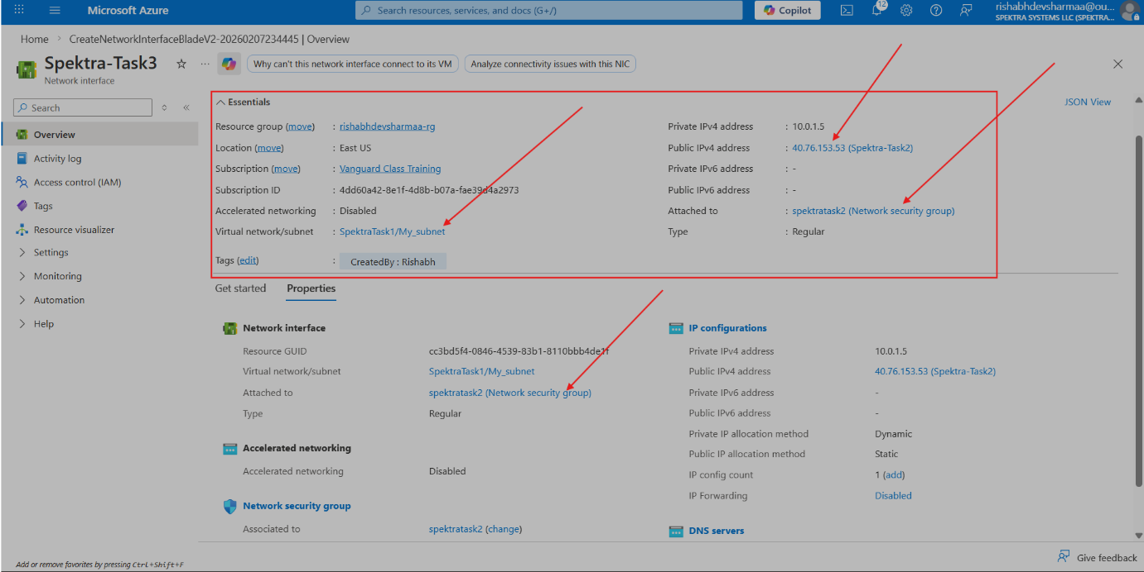

Task 4: Storage Allocation
- Create a Managed Data Disk.
- 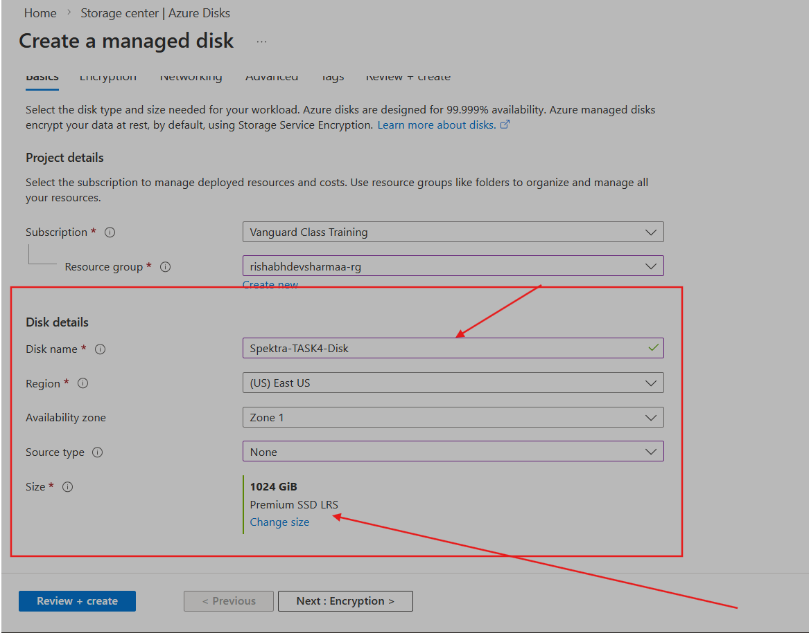

- Constraint: This disk must be physically located to ensure zero-latency attachment to your compute resource.
- 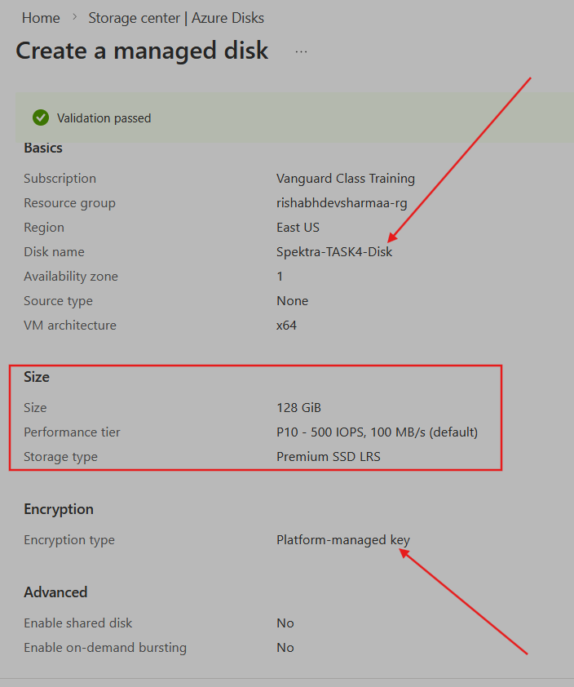

Task 5: Final Assembly (Compute)
- Deploy a Virtual Machine.
- 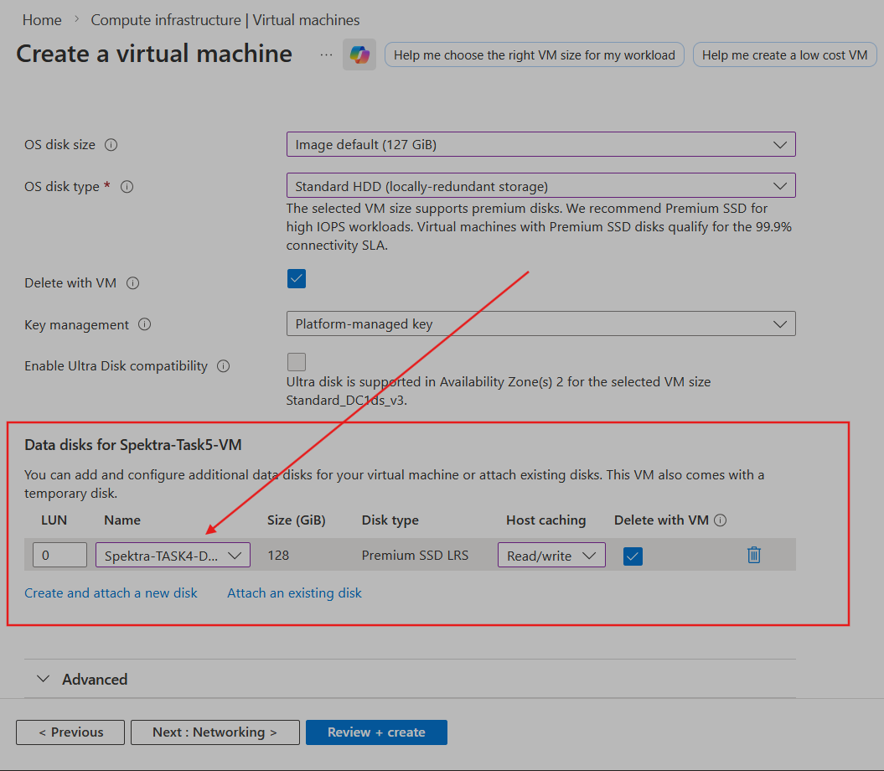
- 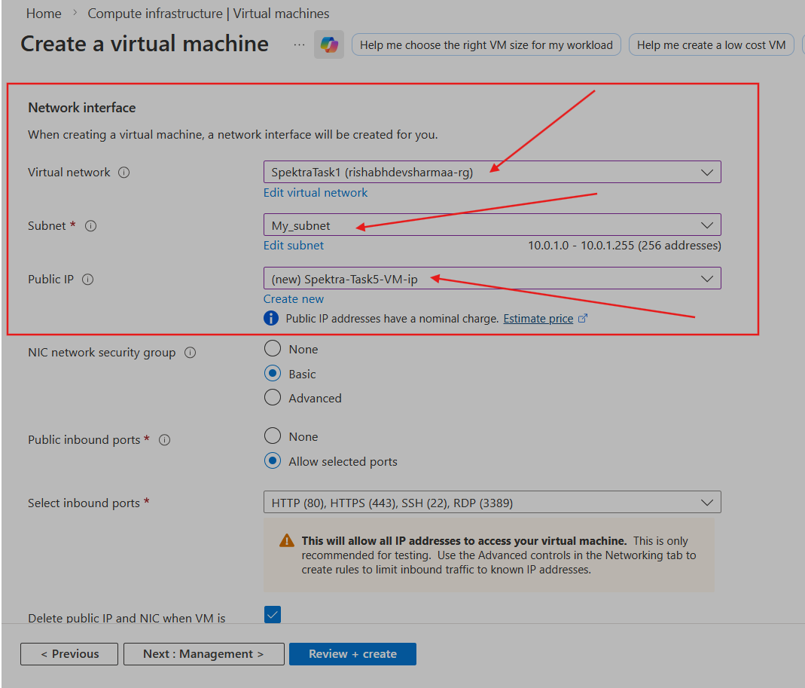
- 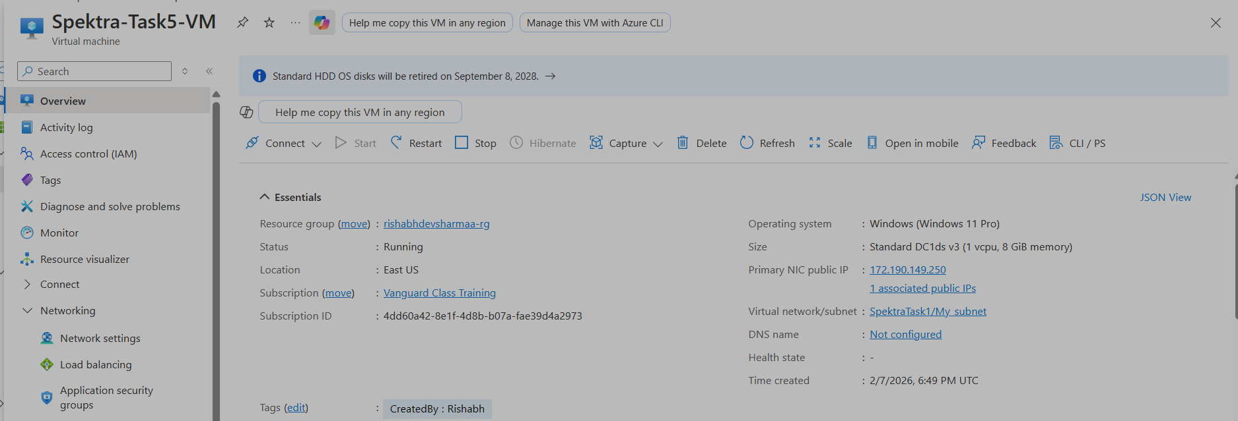
- Requirement: Do not create new networking or storage during this step. You must attach the NIC and the Data Disk you prepared in Tasks 3 and 4.

ask 6: Validation
- Log in to the machine and verify that the extra data disk is visible and ready for use.
- Deliverables:
  - A screenshot of the "Topology" view in the Azure portal showing the relationship between these resources.
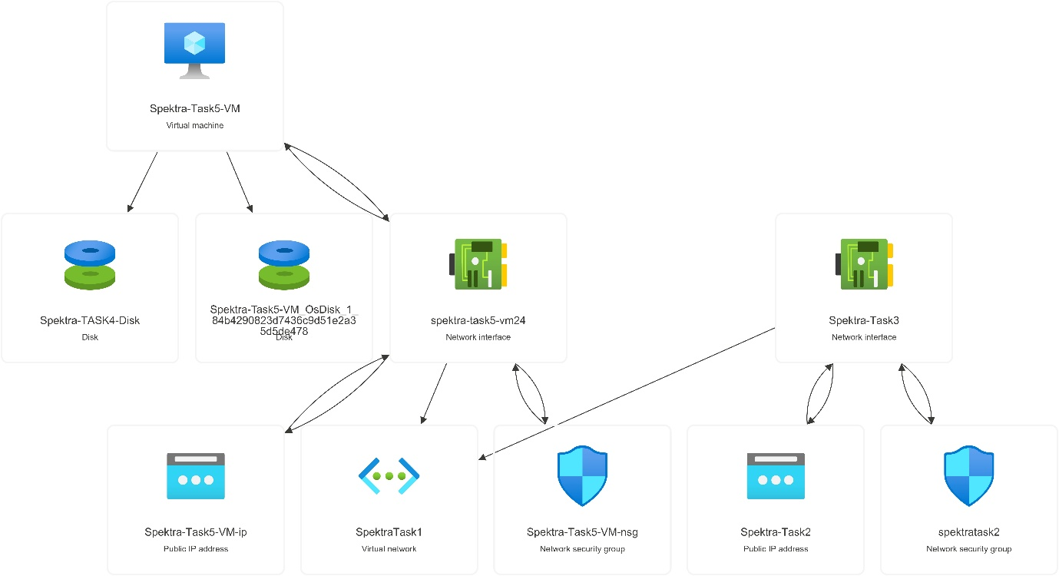
  - Screenshot of each resource deployment from the deployments page
- 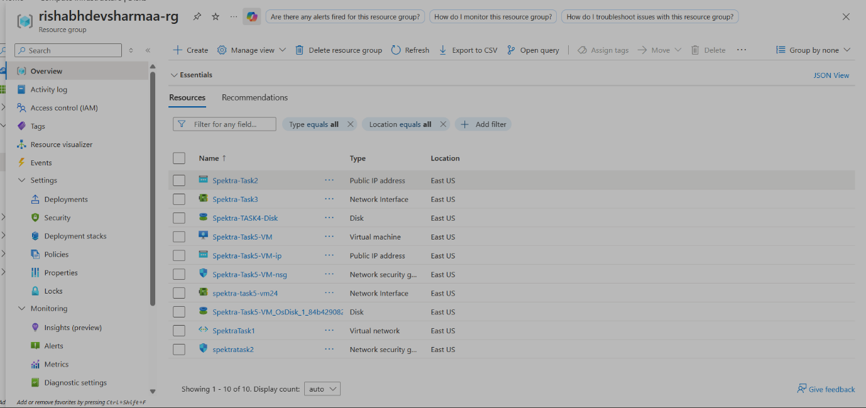

  - Document with the necessary information like VM, VNet SKU's, IP addresses etc

ADDITIONAL INFO:

